PARENT PROCEDURE ON SCHOOL HUB

- Log into www.schoolhub.co.uk
- Enter username/email and password (case sensitive)
- Check it is you and your child/children
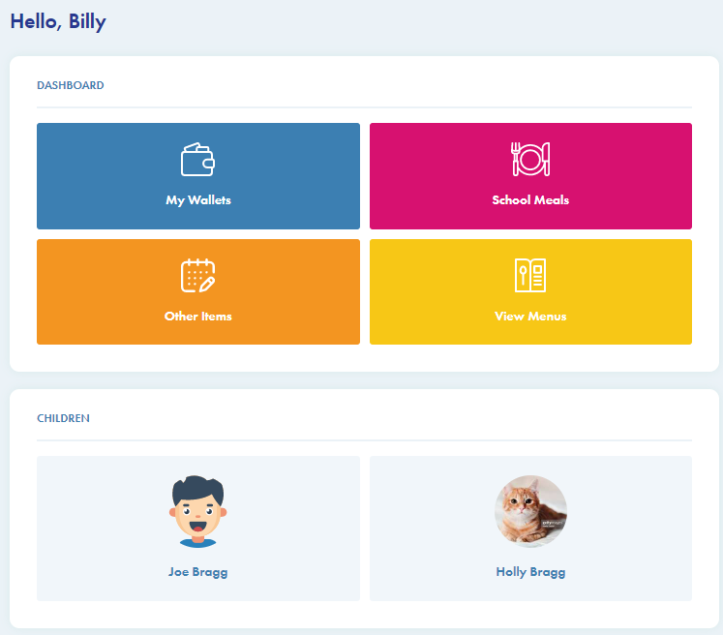

Adding Funds
- Click the ‘my wallets’ button (necessary only for children whom you pay for)
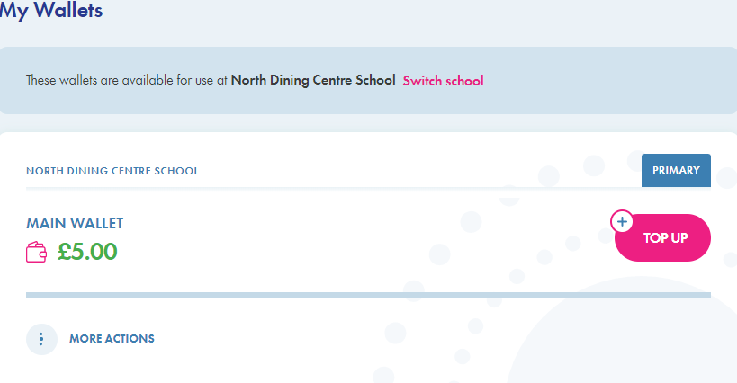
- If you have children in different schools, you will need to select the school before making a payment
- Click on the button
- Enter the amount you wish to credit your account with
- Click the box to agree the T&Cs
- Click ‘make payment’
- Follow the instructions on screen to make your secure payment
- When completed, your wallet total will update

Pre-ordering meals
- Click on ‘School Meals’ button and choose a child as appropriate if you have more than on child. You will need to order for each child individually
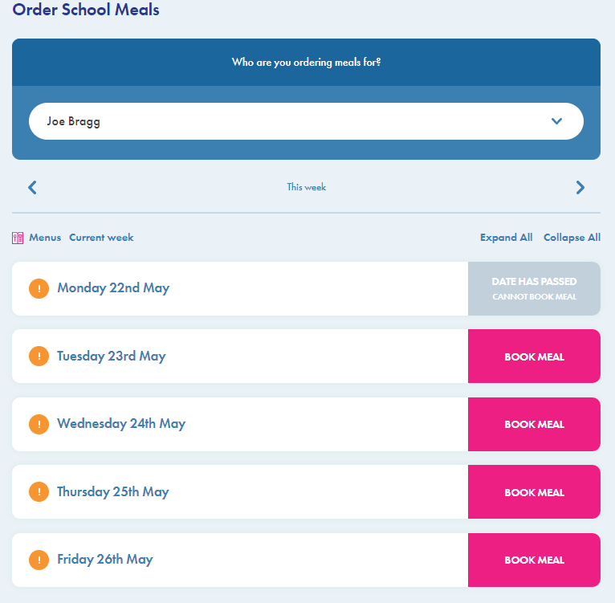

The above screen will appear showing the meals available for that week. You have until 9.30 each morning to order a meal for that day or you can pre-order 2 weeks in advance.
- Click on the ‘book meal’ button
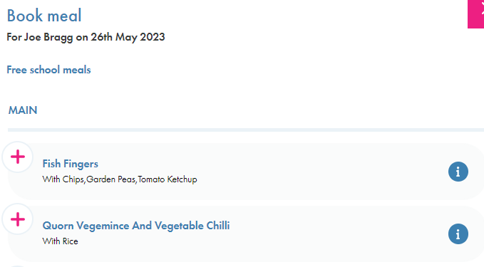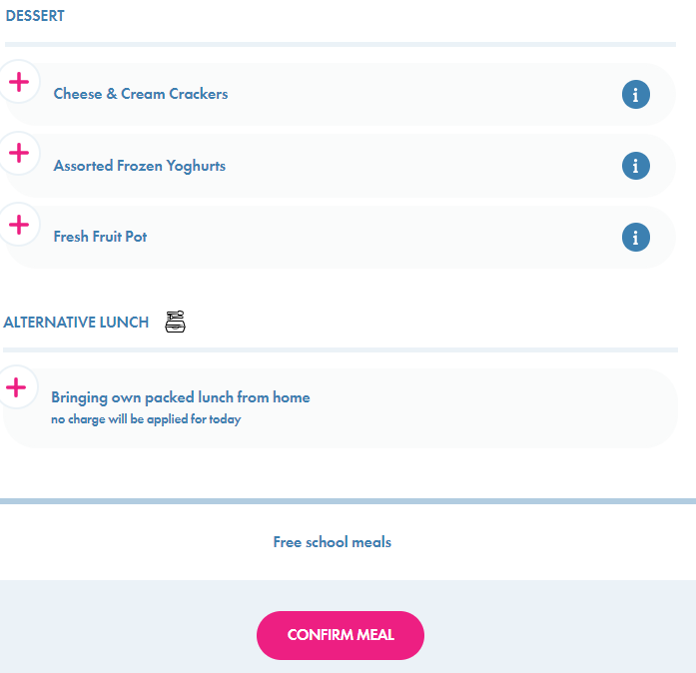

- Click on the chosen main and dessert option, or indicate if sending a packed lunch from home
- Click on the ‘confirm meal’ button. At this point your wallet will be debited if appropriate- you do require a credit balance to order meals for children you pay for
- Once chosen, the meal choice will be confirmed where you can edit or cancel & refund
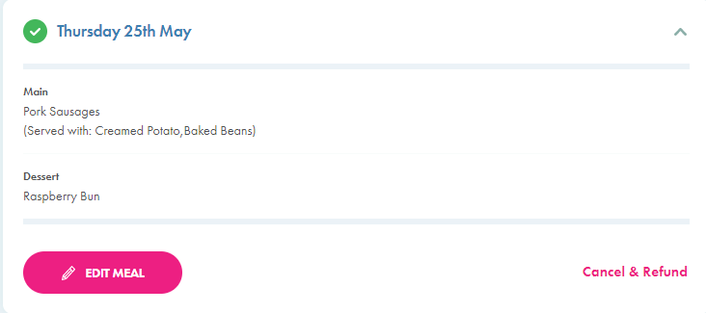
- You may order three weeks in advance and look back at previous weeks by clicking the arrow buttons at the top of the menu page. If your child has ordered in school you can see what they have ordered here
- On the menu page, if you click on the this will give you details of the allergens, nutrition and ingredients within the meal. If your child has an allergy or dietary requirement please inform the school ASAP.
My Account
Click on this symbol  at the top of the page to update your name, email, password, set up 2FA etc., as below

Please note that recurring payments are not yet available.

Accounts & Request a Refund

From the Wallets page (see above), click on ‘MORE ACTIONS’. From here you can view all your transactions or request a refund for any monies on your primary account.

Please go to the Menu page at the top of the page  to download a full user guide.

If you are experiencing any problems please first speak with your school or contact schoolhubsupport@orian.co.uk

