PARENT USER GUIDE
Welcome to School Hub (formerly Lunch Shop). Following feedback, School Hub has been designed for parents with mobile phone optimization in mind and we hope that you find the website brighter, modern and easy to navigate around.
Great news – you can have one log in if you are a parent at more than one school and also have more than one parent/carer attached to a child. Please speak with one of your school admin or Orian to find out more.
If you wish to change the language in School Hub please scroll to the bottom of the screen and select as appropriate.
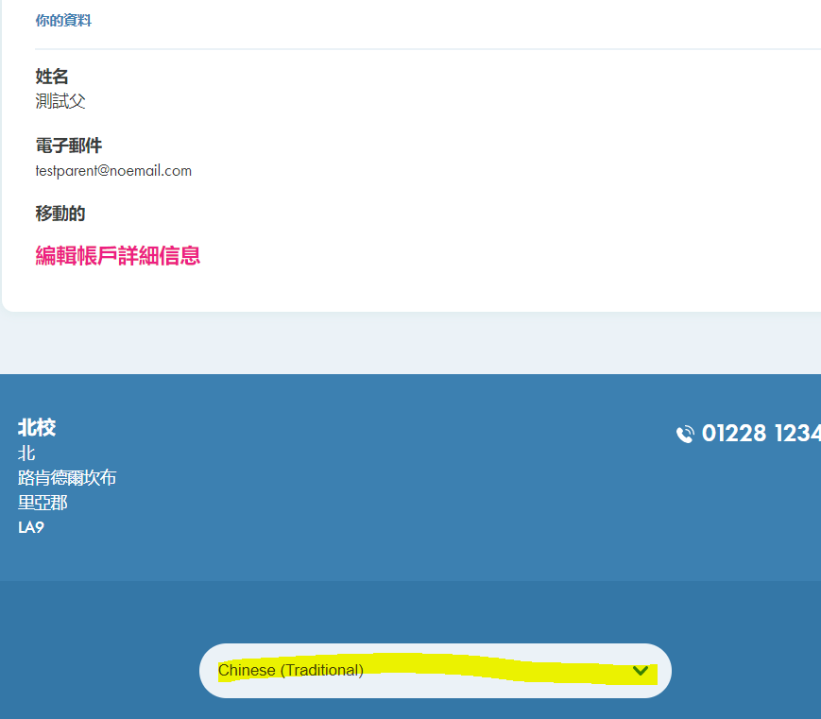

My Wallets

From the My Wallets links on your dashboard, you have the following options. If your child has a free school meal then you do not need to top up your wallet to order meals.
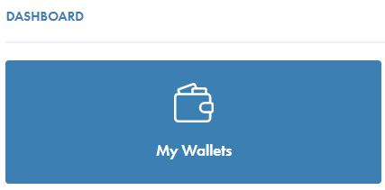

Top Up

Click the TOP UP link to add funds onto your Main Wallet account only.

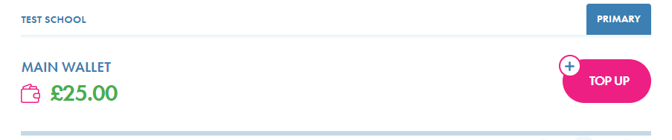
- Choose the amount you wish to top up – see below
- Set up a recurring payment which can be daily/weekly/monthly if you wish
- Tick the T&C’s box once read
- Click on Make Payment
- Input your debit/credit card details – we do not accept Paypal

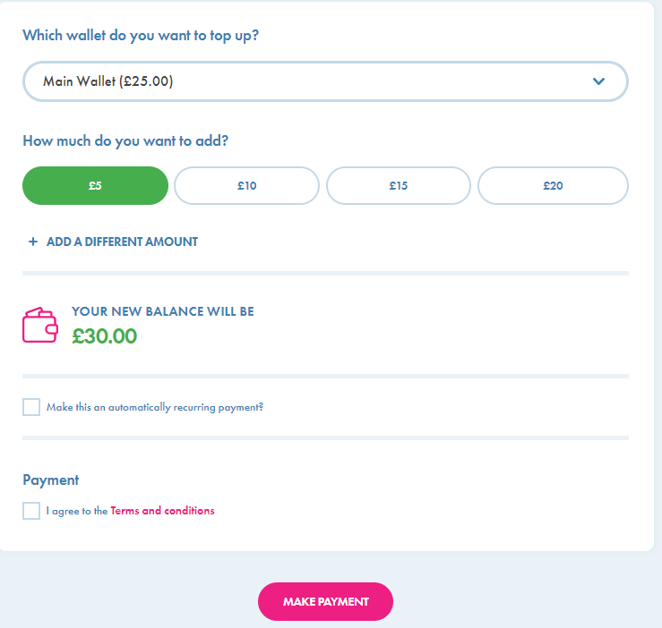

If you are a parent in more than one school, you must choose the school before topping up your wallet. The same wallet cannot be used across all schools due to accounting purposes.

More actions

If you click more actions you can:
- Transaction History - View your transaction history on this wallet
- Transfer funds - you may transfer funds to another wallet items if your school takes payment for trips/clubs etc and wish to keep the transactions separate
- Request a refund – you may request a refund of all or part of your credit balance, from your Main Wallet only. If you have funds in another wallet you will need to transfer these back into your main wallet to request a refund
- Contact school – this will send a message direct to the school

School Meals



Ordering a meal

Click on School Meals box on your dashboard to order meals for your child. You have until 9.30 in the morning to order a meal. Your school will advise if they have a different cut off time. You will require a credit balance to order a meal for a child you pay for.
- Choose the child you wish to order for – see below
- Click on the Book Meal button to see the menu.
- Choose the main and dessert – see allergen info below
- Click on ‘confirm meal’. You will require a credit balance if your pay for a meal.

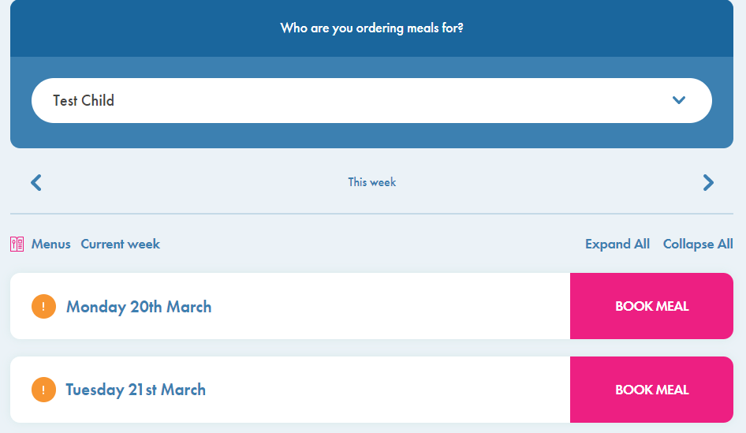

The meal transaction will appear on your wallet transaction page and the monies debited from your balance when you confirm the meal (if you pay for a meal).

Edit or cancel meals

You can edit or cancel a meal by clicking back into the School Meals box and either clicking on edit or cancel meal. If you wish to re-order, follow the steps above.

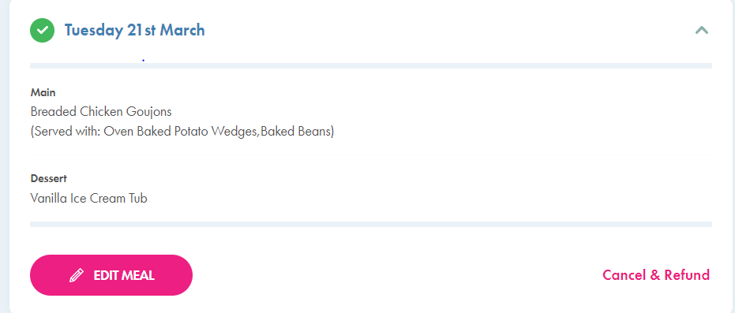

The meal transaction will appear on your wallet transaction page and the monies credited to your balance when you cancel the meal (if you pay for a meal).

Allergen info – if your child has one of the 14 major allergens please contact School Admin to add this to their profile. Once added, if a meal has the same allergy you will be unable to order this meal. If your child has an other allergen/intolerance then please click on the information button next to the meal to see allergen/nutritional/ingredients of that meal. If you require a detailed spec of an ingredient please contact schoolhubsupport@orian.co.uk with your name, school and the date of the meal.

You may order 2/ 3weeks in advance by clicking on the arrow buttons under the child’s name.

View Menus



You can view the menus either on the school meals pages or by clicking the ‘view menus’ box on your dashboard.
- Click on the down arrow next to the week to see the days
- Click on the + sign next to the day to see the menu

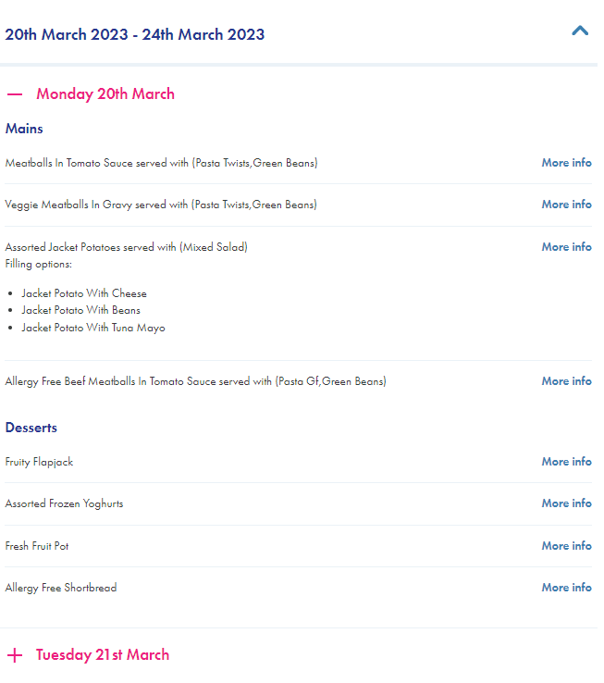
- Click on ‘more info’ to view allergens/nutrients/ingredients – see below

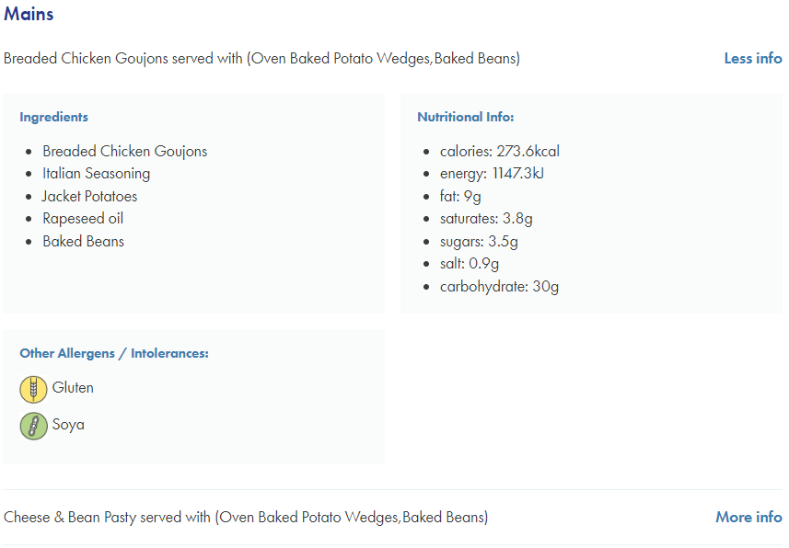

If you require a detailed spec of an ingredient please contact schoolhubsupport@orian.co.uk with your name, school and the date of the meal.

You can also click on the ‘book meals’ link from this page to book a meal – see ordering a meal section

Other Items



If your school takes payment for trips, clubs etc, you will find the appropriate item in this section to make a booking/payment. For all items you will require a credit balance. If you do not have enough funds a message will appear on the screen.

Click on ‘other items’ on your dashboard
- Select the child you wish to order for
- Select the item type if you wish
- Locate the item and click on ‘place order’
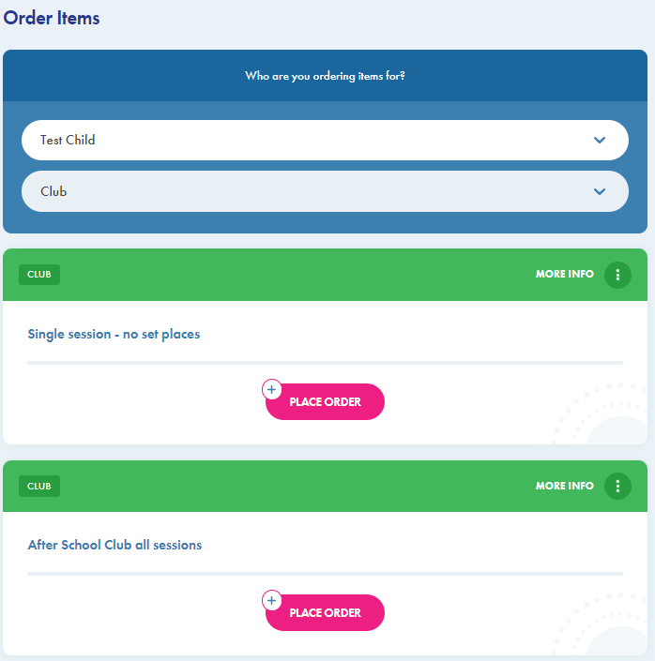

CLUBS – booking
- If the club has more than one session available eg after school club, choose the session you wish to book
- Select the date/dates you wish to book and click ‘confirm’ at the top of the calendar
- Choose the wallet you wish to pay from if you have more than one available
- Add a note to the school admin if you wish
- Click on ‘place order’
- If a permission slip has been attached, please choose as appropriate
- Click on ‘place order’. If a date is unavailable, a message will appear to let you know. Please take this date out of the calendar and proceed
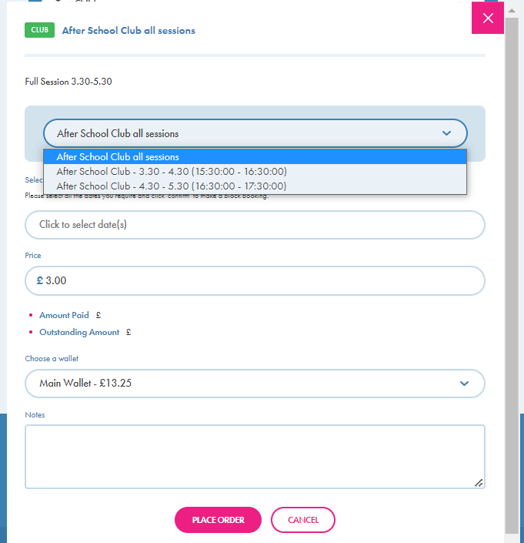

CLUBS – view bookings and cancellation
- Click on ‘View history’
- Filter by dates if you wish
- To cancel - find the booking and click on ‘cancel and refund’ if your school are allowing parents to cancel a club. If not please contact your school admin.
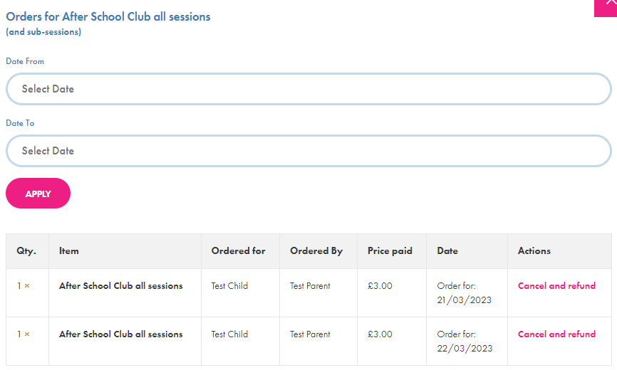

TRIPS – bookings for a set amount of monies either single payment or by instalments
- ONE OFF PAYMENT – Choose the wallet you wish to pay from if you have more than one available. You will be unable to amend the price.
- Click on ‘place order’
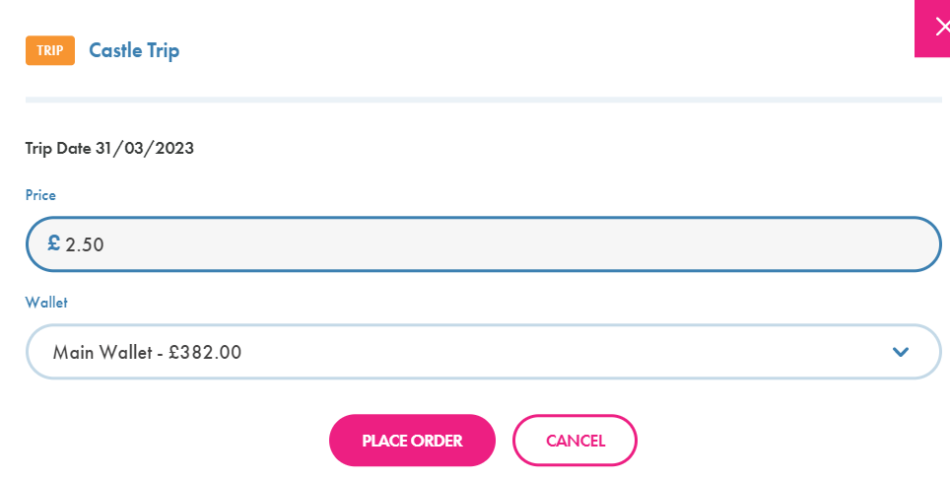

- INSTALMENT PAYMENT – Input the amount you wish to pay
- Choose the wallet you wish to pay from if you have more than one available
- Click on ‘place order’
- Click on ‘make additional payment’ to make further payments

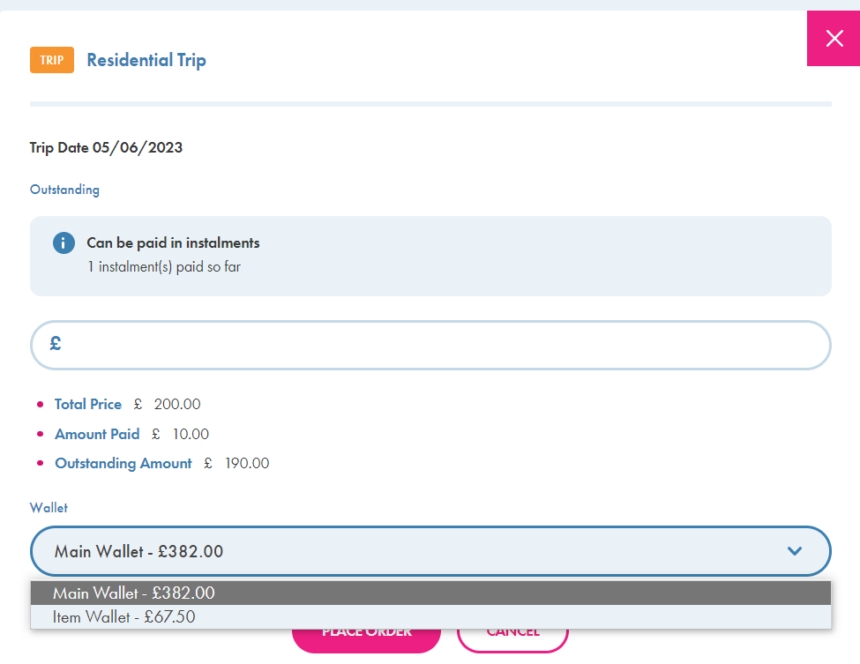

TRIPS – view bookings/payment or cancellation
- Click on ‘view history’ to view your payments/outstanding balance and make additional payments
- Click on ‘cancel and refund’ if your school allow you to cancel. If not please contact your school admin

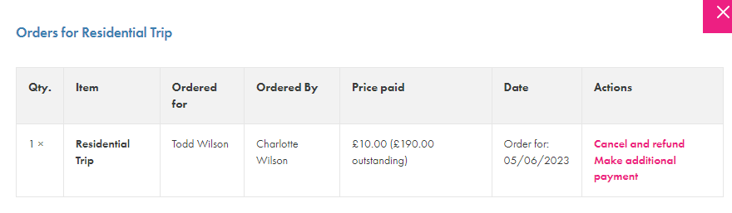

OTHER – this can be used for non set amount items eg, making a payment for uniform throughout the year for varying amounts. There are various ways the school can set up an ‘other’ item so not all have screen shots
- Input quantity if applicable (if for something like school play tickets)
- Input the amount you wish to pay if it is not a standard price
- Choose the wallet you wish to pay from if you have more than one available
- Input something into ‘notes’ eg T Shirt size S so the school know what you are paying for
- Click on ‘place order’

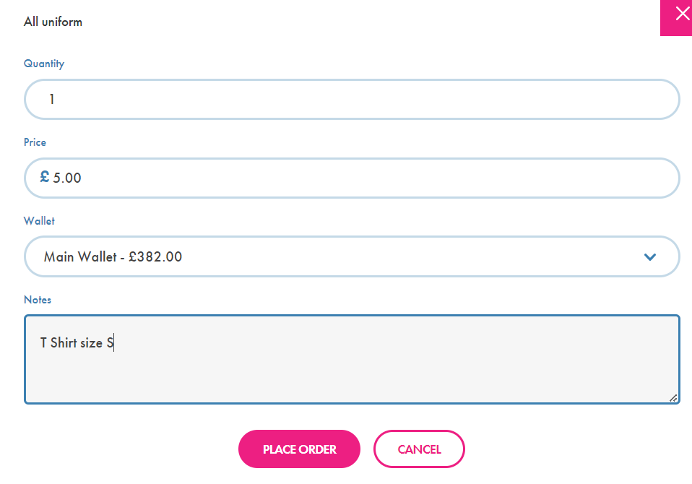

OTHER – view bookings and cancellation
- Click on ‘View history’
- To cancel - find the booking and click on ‘cancel and refund’ if your school are allowing parents to cancel. If not please contact your school admin.

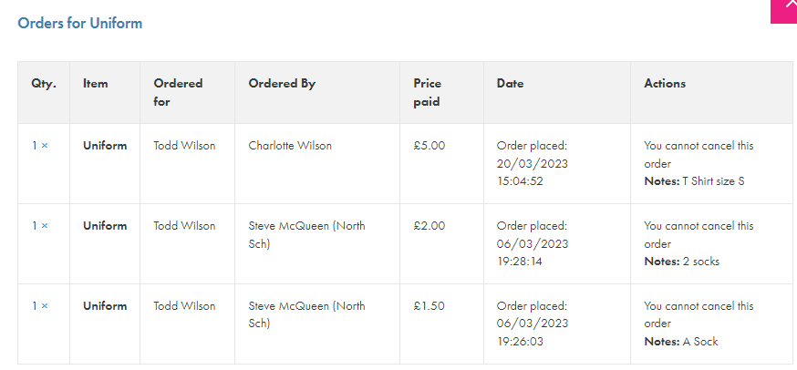

Children

Your child/children who are attached to you are visible on your home page. If you click on your child you can view basic information eg name, school, group, allergens, meal cost. If any of these details are incorrect please contact your school admin.
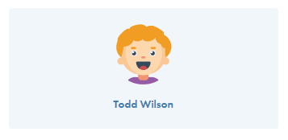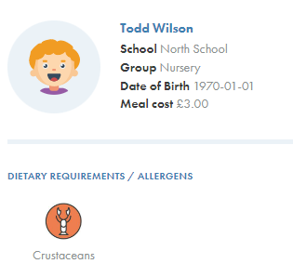

Reminders

In this section reminders will be visible for:
- Meals not ordered with a link to the meal ordering page
- Any messages from the school
- Confirmation of refunds requested and actioned
- Payment info
- Upcoming trips/clubs

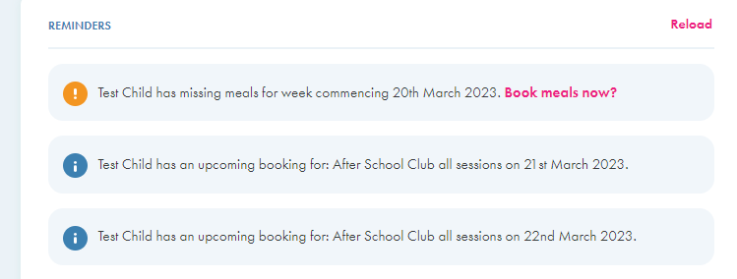

Quick Links

In this section you can quickly access some functionality within School Hub:
- Reset Password – Change your password should you need to. If you have forgotten your password when logging into School Hub, you can click the ‘Forgot password’ from the login page
- Top Up Wallet – takes you direct to the top up page to input your card details
- Contact School – Allows you to compose a message a message to the school admin
- Log Out – takes you to the login page
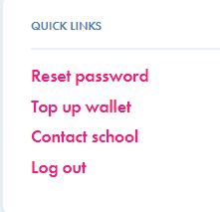

Your Details

This confirms your name, email address and contact number if you wish to add it. You are also able to add your address if you so wish. These details are not shared with any third party organisations but do allow the school and Orian to contact you with regards to any queries on your School Hub account. You can edit your details by clicking on the link.

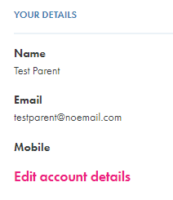

 Home symbol, top left hand of screen

Returns you to the home screen from wherever you re in School Hub.

 Menu symbol, top right hand of screen

Links to pages covered above and also report a problem to Orian and download the user guide

- My Wallets
- School Meals
- View Menus
- Other Items
- My Children
- Contact School
- Report a Problem
- User Guide

 My Account symbol, top right hand of screen

Links to :
- My Details
- Recurring Payments
- Update Password
- Account Security – 2 factor authentication
- Help and User Support
- Logout

